Hope in Jesus: The Only Way to True Peace
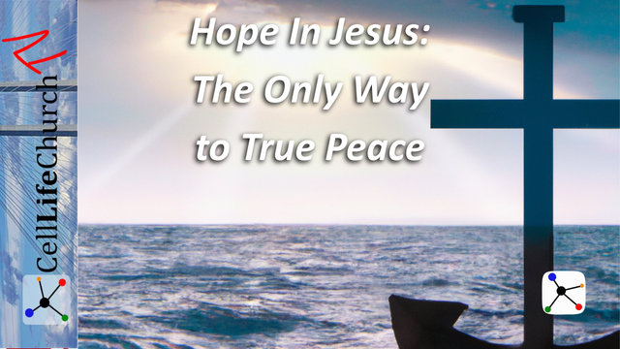
In a world of broken promises and shifting ground, where can you anchor your soul? Discover how hope in Jesus brings true peace, lasting joy, and eternal purpose.

Introduction
We live in a time when people are searching desperately for hope. Many look to governments, leaders, bank accounts, or affiliations with powerful organizations. But each of these ultimately fails to deliver lasting security and peace. As followers of Christ, we know where true hope is found; it is in Jesus alone. He never changes, never fails, and always keeps His promises. Today, we are going to explore why hope in Jesus is the only real and unshakable hope and how we can live that out daily.

Hope in Jesus Anchors Us in Life's Storms
We read how our hope is anchored in Jesus in Hebrews 6:19-20, which says:

Hebrews 6:19-20
(19) We have this hope as an anchor for the soul, firm and secure. It enters the inner sanctuary behind the curtain, (20) where our forerunner, Jesus, has entered on our behalf. He has become a high priest forever, in the order of Melchizedek.
An anchor is a powerful symbol of stability and security for ships. When tossed by wind and waves, sailors depend on their anchor to keep them from drifting into danger. Similarly, life can toss us about with anxiety, fear, and uncertainty. The storms may be financial, relational, emotional, or even spiritual, but our hope in Jesus secures us; it is our anchor.
Jesus, our High Priest, has entered the Most Holy Place on our behalf. Because of His sacrifice, we have a direct connection to God. This hope does not fluctuate with our emotions or circumstances. It is grounded in God’s unchanging promises. When everything else feels like it's slipping away, Jesus holds firm.
Think of the last time you felt truly shaken. What held you steady? Take inventory of your current emotional and spiritual state. Are you feeling tossed by a storm of worry, depression, or conflict? Identify specific areas where you are feeling unsteady and speak the truth of Hebrews 6:19 into those situations. Start a personal “Hope in Jesus” list in your journal. Write down God’s promises that apply to your circumstances and revisit them daily.
Set aside 10 minutes each day this week to be still before the Lord. In those quiet moments, anchor your soul in prayer, scripture, and the knowledge that Jesus holds you fast. Let that time become your spiritual anchor in life’s daily waves.

Hope in Jesus Transforms Our Perspective
Once we are anchored in the unshakable love of Jesus, we are no longer ruled by the storm. That security transforms how we see everything, from daily frustrations to eternal purpose. We all see things a little differently, and our situations and experiences shape that perspective. The Apostle Paul teaches us in Romans 15:13:

Romans 15:13
(13) May the God of hope fill you with all joy and peace as you trust in him, so that you may overflow with hope by the power of the Holy Spirit.
Our perspective shapes our experience of the world. When our eyes are fixed on temporary things like political headlines, financial markets, or personal achievements, our peace rises and falls with the tides of this world. But hope in Jesus lifts our eyes above the noise and reorients us toward eternal truth.
Paul writes that the God of hope fills us with joy and peace as we trust in Him. Trust is the key. The more we trust Jesus, the more room He has to pour His Spirit into us. That is how we begin to overflow with hope, not a trickle, not barely enough, but a full and abundant hope that spills out to encourage others.
Do you find your perspective darkened by worry, cynicism, or negativity? Start a habit of “hope declarations.” Each morning, speak a truth from scripture that reminds you of God’s promises. When situations challenge your peace, pause and ask: “Am I seeing this through the lens of heaven or the lens of fear or frustration?” Let the Holy Spirit reframe your view.
Write Romans 15:13 on a card or sticky note and place it somewhere you will see it often; your bathroom mirror, your dashboard, or your desk. Each time you see it, invite God to transform your thinking and renew your hope. Then look for someone in your life who needs a fresh perspective and share that hope with them.

Hope in Jesus Leads Us to Eternal Life
Jesus makes a powerful declaration that we read in John 14:6, which says:

John 14:6
(6) Jesus answered, "I am the way and the truth and the life. No one comes to the Father except through me.
This statement from Jesus is bold, exclusive, and deeply comforting. He does not say He knows the way. He says He is the way. He does not just speak truth, He is the truth. He does not just offer life, He is the life. In a world full of division and shifting moral standards, Jesus stands as the unchanging gateway to God.
People often place their hope in being “good enough,” believing in karma, or aligning with causes or institutions. But none of those can bridge the gap between humanity and a holy God. Only Jesus can. He conquered sin and death to offer us eternal life. This hope is not just for when we die, it gives us meaning and direction now.
Imagine the peace that comes from knowing eternity is settled. Live every day with the end in mind. When we remember that eternity is real and Jesus is the only way to get there, it changes our priorities. We stop chasing temporary success and start investing in eternal impact. Reflect on your life. Ask yourself, “Are my decisions today building up treasures in heaven or simply feeding temporary desires?”
If you have not fully surrendered your life to Jesus, today is the day. He is the only way to eternal life. And if you have, recommit to living with eternity in view. Find someone who does not know Jesus and begin a conversation. Share your story of how placing your hope in Jesus has changed your life.

Conclusion
Our world is desperately searching for something solid to hold onto, something to believe in, something to trust. But everything this world offers is temporary and shifting. Governments change. Leaders fail. Finances fluctuate. Organizations disappoint. But Jesus remains the same: faithful, loving, and full of power to save.
Hope in Jesus is not a vague wish. It is a confident expectation rooted in His unchanging nature and eternal promises. He anchors us in life’s storms, transforms how we see the world, and leads us into eternal life with God. When we truly believe that Jesus is the way, it changes everything: our attitudes, our decisions, our purpose, and our peace.
As you reflect on this message, ask yourself honestly, “Where is my hope anchored?” If it is in anything other than Jesus, now is the time to re-center your life on Him. Commit to deepening your trust in Christ this week. Spend time in His Word, speak hope over your life and family, and boldly share the reason for your hope with someone else.
If you've never placed your hope in Jesus, there's no better moment than now. Let today be the day you say, “Jesus, I trust You.”
If your hope is already in Jesus, be encouraged, He is faithful. Keep anchoring others by living boldly and sharing freely. The world needs your witness. The world needs what you have: hope that never fails and hope that is only found in Jesus.

