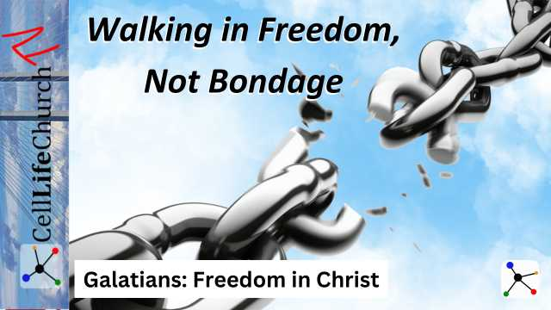Walking in Freedom, Not Bondage

Many believers are free in Christ but still live as if they are captive. How can we break free and truly embrace the life Jesus secured for us? Today, we will discover how to walk daily in the freedom Christ has given us, resist returning to spiritual bondage, and live by the Spirit.

## Introduction

Welcome to the next teaching in our series, *Galatians: Freedom in Christ*. Throughout this journey, we have explored Paul’s powerful message to the Galatians, reminding us that true freedom is found in Christ alone.

We began by understanding the foundation of our faith in *The True Gospel – No Substitutes*, we saw how the gospel can be distorted and why we must hold onto the unchanging truth of Jesus Christ. In our second teaching, *Grace Over Law – Faith That Sets Us Free*, we learned that salvation comes by grace through faith, not by works of the law. Last time we discussed *The Power of Faith* and how it transforms us from slaves to beloved children of God.

Today, we dive into what it means to walk in freedom daily, not slipping back into spiritual bondage. Many believers are freed by Christ but continue living as if they are still captive. How do we break free from this mindset and truly embrace the life Jesus secured for us? Let’s learn how.

## Christ Has Set You Free – Don’t Go Back

Paul teaches us about the freedom we receive from Jesus in Galatians 5:1

### Galatians 5:1

(1)  It is for freedom that Christ has set us free. Stand firm, then, and do not let yourselves be burdened again by a yoke of slavery.

Paul is crystal clear, Jesus did not free us so we could return to the chains of sin, legalism, or fear. The Galatians were being tempted to return to the law as a means of righteousness, but Paul warns them, and us, to stand firm in the freedom Christ purchased with His blood.

Many Christians struggle with old habits, guilt, and performance-based faith. Some feel they must continually prove their worth to God, living under a weight of religious obligation rather than grace. Others battle with shame from their past, unable to fully embrace the new identity Christ has given them.

Are you living in true freedom, or are you allowing past burdens to weigh you down? Take a moment today to identify any areas where you are still living in bondage—whether it is fear, legalism, or shame. Write them down and pray over each one, declaring, “Christ has set me free, and I will not return to slavery.”

## Freedom in Christ is Not a License to Sin

We learn from Paul that we are called to be free, but there are limits in Galatians 5:13

### Galatians 5:13

(13)  You, my brothers and sisters, were called to be free. But do not use your freedom to indulge the flesh; rather, serve one another humbly in love.

Freedom in Christ does not mean we live however we please. Paul reminds us that true freedom is not about self-indulgence but about love and service. When we misuse our freedom to justify sin, we enslave ourselves all over again.

Consider the story of the prodigal son in the gospel of Luke 15:11-32. He took his inheritance and wasted it in reckless living, thinking that freedom meant doing whatever he wanted. But he found himself enslaved—hungry, broken, and desperate—until he returned to his father. True freedom is not found in living for ourselves but in living in loving obedience to God.

Are there areas where you are misusing God’s grace as an excuse? True freedom leads to holiness, not selfishness. How can you use your freedom to bless others?

This week, find one way to serve someone in love—whether through encouragement, generosity, or practical help. In other words, be the Church. Freedom in Christ should lead to a life that reflects His love.

## Walk by the Spirit, Not the Flesh

Paul teaches us to walk by the Spirit, not the flesh in Galatians 5:16-17

### Galatians 5:16-17

(16)  So I say, walk by the Spirit, and you will not gratify the desires of the flesh.  (17)  For the flesh desires what is contrary to the Spirit, and the Spirit what is contrary to the flesh. They are in conflict with each other, so that you are not to do whatever you want.

Living in freedom means choosing to be led by the Holy Spirit rather than by our own sinful nature. There is a constant battle between the desires of the flesh and the leading of the Spirit. Victory comes when we surrender daily to the Spirit’s guidance.

Do you find yourself struggling with the same temptations and habits? Walking in freedom means yielding to the Holy Spirit moment by moment. The more we listen to His voice, the stronger our spiritual discernment becomes.

Here are three practical ways to cultivate a Spirit-led life:

1. Daily Surrender – Begin each day by praying, “Holy Spirit, guide my thoughts, words, and actions today.”
2. Scripture Meditation – Regularly read and reflect on God’s Word to align your heart with His truth.
3. Intentional Obedience – When the Spirit prompts you to act, whether to resist temptation or step out in faith, follow His lead without hesitation.

Start each morning by asking the Holy Spirit to guide you that day. Write this down and keep it as a daily reminder. The more we walk in step with the Spirit, the more we will experience true freedom in Christ.

## Conclusion

Walking in freedom is not just a one-time event, it is a daily choice. Christ has set us free, but we must actively live in that freedom.

* Freedom is ours in Christ, do not go back to bondage.
* True freedom leads to love and service, not sin.
* Walking in freedom requires walking by the Spirit.

Freedom is not just being set free, it is learning to live free.

We will dive deeper into what it means to truly live by the Spirit in our next teaching, *Life in the Spirit – Bearing Good Fruit.* We will explore how walking in the Spirit produces the fruit of love, joy, peace, and more in our lives. Don’t miss it.